 **KIST COLLEGE OF MANAGEMENT**

**Full Marks: 60**

**Pass Marks: 36**

**Time: 3 hrs.**

**Affiliated to Tribhuvan University**

**Kamalpokhari, Kathmandu**

**September, 2024**

**Pre - Board Examination**

**BIM / Fourth Semester / IT 239: Web Technology II**

*Candidates are required to answer the question in their own words as far as practicable.*

**Group – A**

**Brief Answer Questions: [10 x 1 = 10]**

1. What are the root directories for XAMPP and WAMP servers?
2. What is type casting, and what are the two types of type casting available in PHP?
3. Write a function that converts array into a json format.
4. What is the use of trim() and chop() in PHP? Provide examples.
5. What is a trait in PHP, and which keyword is used to include a trait in a class?
6. What is the use of header() function in PHP?
7. What is a destructor? How do you construct destructor in PHP?
8. What is the use of mysqli_connect() function? What parameters are required for this function?
9. Differentiate between authentication and authorization.
10. What do you mean by ORM? Explain

**Group – B**

**Short Answer Questions (Attempt Any Five Questions): [5 x 3 = 15]**

1. What are anonymous functions in PHP? Explain with syntax and example.
2. Why is it important to write modular code? What is the difference between require() and include() in PHP?
3. What is an associative array in PHP? How can you create a two-dimensional associative array and access the first and last values?
4. What is a namespace in PHP? Explain the concept with examples.
5. What do you mean by access modifiers? Explain.
6. Explain MVC pattern.

**Group – C**

**Long Answer Questions (Attempt Any Three Questions): [3 x 5 = 15]**

1. What are Control Statements in PHP? Explain their types with examples.
2. Differentiate between Abstract Class and Interface. Write a PHP script to illustrate the concept of Hierarchical Inheritance.
3. What is a CSRF token? Differentiate between filter_has_var() and isset() in PHP.
4. Consider a database named “KIST_BIM” with a table called Users (uid, name, address, email, password). Write a PHP script to retrieve and display all the records from the Users table in a tabular format.

**Group – D**

**Comprehensive Answer Questions: [2 x 10 = 20]**

1. Develop a PHP application that allows users to set their preferences for website themes (e.g., light mode or dark mode) and stores these preferences using cookies. The application should have the following functionalities:
2. A form that allows users to select their preferred theme and submit their choice.
3. Upon submission, the user's preference should be stored in a cookie, and the theme should be applied immediately based on the selection.
4. On subsequent visits to the website, the application should automatically apply the stored theme preference by reading the cookie.
5. Provide a button to reset the theme preference, which should delete the cookie and revert the website to its default theme.

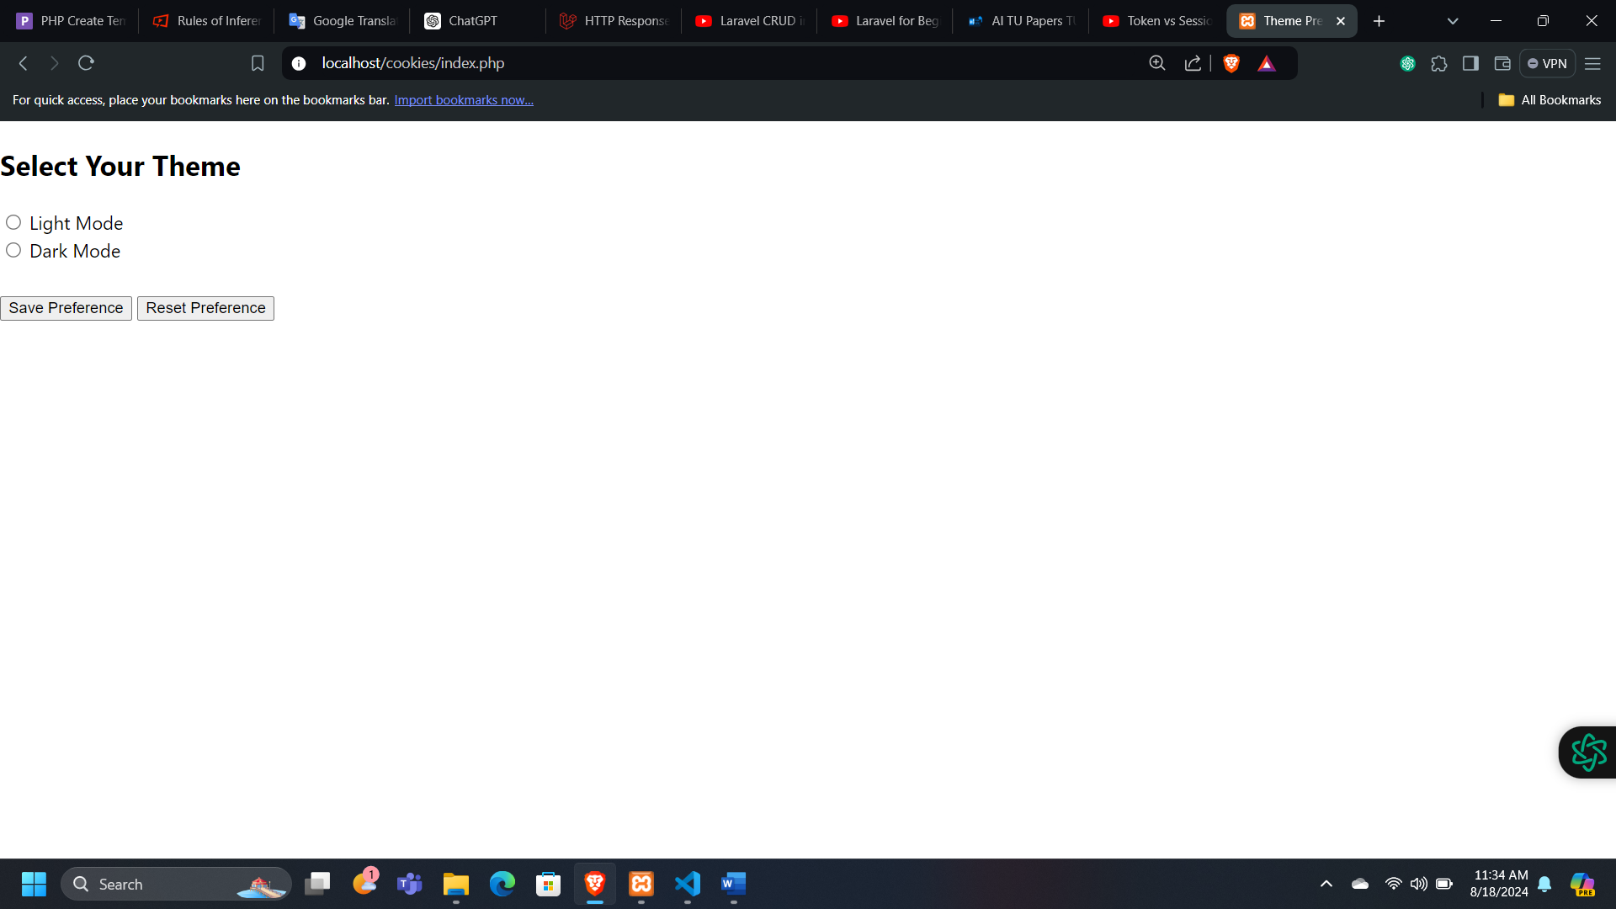

Fig. Sample UI

1. 1. What is Laravel? Explain its key features and architecture. Additionally, what is the difference between a framework and a CMS?
   2. Write short notes on:

i. Routing in Laravel

ii. Blade Template

iii. Migration

*****